What Were They Thinking? Unlocking the Secrets of the Teen Mindset

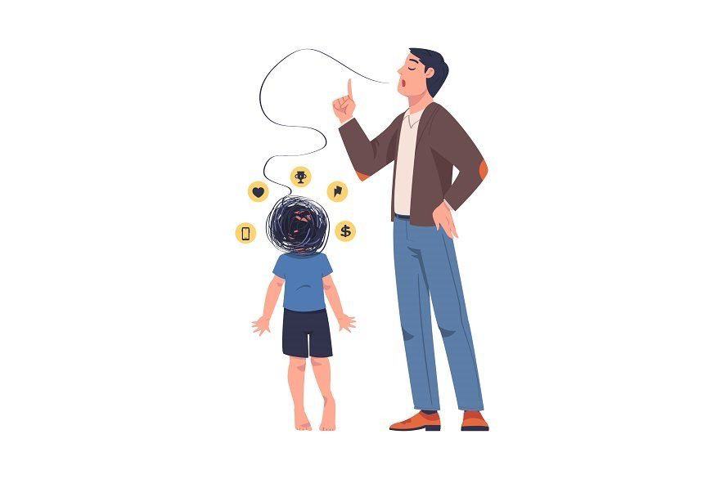
Have you ever looked at your teenager after a questionable decision and asked, "What were you thinking?" only to be met with a blank stare or a frustrated shrug? If so, you're not alone. This is one of the most common moments of disconnect between parents and teens, but the answer isn't about defiance—it's about biology.
Welcome back to the Ikigai Teen blog. Today, we're diving into the fascinating, and sometimes frustrating, world of the teenage brain to understand why they don't think like adults... yet.

The Brain Under Construction
Here’s a fact that changes everything: the human brain isn’t fully developed until around age 25. Your teenager might have an adult-sized body, but their brain is still a work in progress.
The two key areas to understand are the prefrontal cortex and the amygdala.
- The Prefrontal Cortex (The CEO): This is the part of the brain right behind your forehead responsible for logic, impulse control, planning, and long-term decision-making. In teenagers, this "CEO" of the brain is still maturing and will continue to develop for the next decade.
- The Amygdala (The Emotion Center): This is the brain's emotional, reactive core. In contrast to the prefrontal cortex, the amygdala is in full swing during the teen years. This means emotions are louder, impulses are stronger, and the need for social approval can feel as vital as oxygen.
This imbalance explains so much. When your teen argues with intense passion, makes a snap decision, or seems to be "all feelings and no logic," it's not a sign of bad parenting or misbehavior. It's their brain's natural growth phase at play. In fact, a Harvard study found that teens are two to three times more likely to take risks when their peers are watching. It's not rebellion for the sake of it; it's a biological drive to experiment, explore, and test boundaries.

The Parent's Dilemma: Expecting Logic from a Brain in Beta Mode
This is where many of us get stuck. We expect adult logic from a brain that's still in its beta version.
Think of it this way: your teen’s brain is like a smartphone that’s constantly installing a major software update. Halfway through the update, you keep trying to open apps and then wonder why they’re glitching. Teenagers aren’t broken; they’re buffering. They look grown up, so we expect instant maturity. But maturity is a muscle, and it builds slowly through guided mistakes, not lectures.

The Digital Pressure Cooker
Now, let's add a uniquely modern challenge into the mix: the overwhelming social and digital pressure. When we were growing up, this all-pervasive element simply didn't exist. Today's teen is navigating a digital environment that is constantly demanding their attention.
Did you know that teens can process over 5,000 social inputs a day through reels, DMs, notifications, and videos? That's a massive cognitive load for any brain, let alone one that is still developing. A 2024 Pew Research survey highlights the impact, revealing that 46% of teens say they feel “addicted” to their phones, while 63% feel pressure to appear successful online.
Imagine this potent combination: a brain still learning self-regulation, flooded by a nonstop dopamine loop from screens. It’s like giving a sophisticated espresso machine to someone who just learned how to boil water. This explains why your teen's attention span, emotions, and motivation can swing so dramatically. They aren’t being lazy—they are simply overloaded.

How to Help: Your Calm is Contagious
This is where you, as a parent, become the most crucial guide. Your teen doesn't need you to fix their brain; they need you to support it while it grows. They need:
- Your calm when they’re chaotic.
- Your structure when they’re scattered.
- Your empathy when they’re emotionally overwhelmed.
One powerful, neuroscience-backed strategy is called "co-regulation." It’s the process where your calm, regulated nervous system can actually help soothe your teen's overwhelmed one. When they are spiraling, a lecture or shouting will only add fuel to the fire. But your steady, quiet energy can help them settle.
Think of yourself as their emotional Wi-Fi—when your signal is stable, their connection improves. As W.E.B. Du Bois wisely said, “Children learn more from what you are than what you teach.”
Let’s be honest, we all have our "Did I really just say that?" parenting moments. One parent recently shared a story that perfectly captures the teen mindset. She asked her son to take a break from his phone, and he replied, “Okay, I’ll take a break… right after this one last motivational reel about taking breaks.”
It’s funny, but it’s also insightful. It’s their way of acknowledging the conflict and saying, “I know this isn't ideal, but I’m trying!” Our job is to meet them at that point of effort, not demand perfection.

The Takeaway: Guide, Don't Fight
Your teen’s brain isn’t working against you; it’s just evolving. They don’t think like adults yet, but your patience, presence, and perspective can help them get there beautifully. Don't fight the process—guide it. And don't take every argument personally; it's often their way of figuring out who they are.
Your role is not to control, but to coach.

